Chapter 16, Problem 79.

For the circuit in Fig. 16.97, find:

(a) I₁/V_{s}
(b) I₂/V_{x}

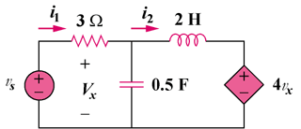

Figure 16.97
For Prob. 16.79.

